Sentimental analysis for marketing

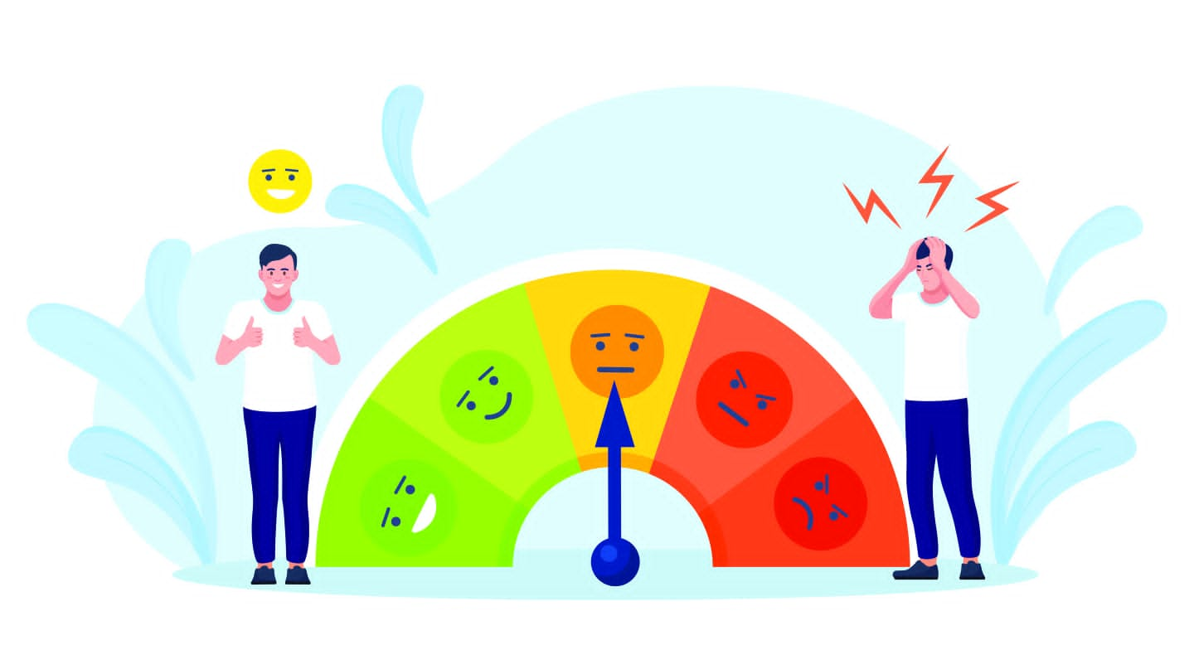

# **Development ideas for sentimental analysis for marketing**

# For development ideas, consider features like sentiment trend analysis over time, sentimental analysis for customer reviews,sentiment-based recommendations, or sentiment-based alerts for extreme reviews. Your source code may vary depending on the technologies and tools you choose, but the core sentiment analysis logic will remain similar.

**Here's I choose sentimental analysis for customer reviews**

# Sentiment Analysis for Customer Reviews:

Develop a system that automatically analyzes and categorizes customer reviews on e-commerce platforms. This can provide valuable insights into product strengths and weaknesses.

## Purpose of sentimental analysis for customer reviews

Sentiment analysis for customer reviews involves analyzing text data to determine the sentiment or emotional tone expressed in the reviews.

**Outline of the development process**

1. **Data Collection**

* **Obtain customer reviews from your data source. You can use web scraping, APIs, or pre-existing datasets.**

1. **Preprocessing**

* **Prepare the data by cleaning and tokenizing the text. This may involve removing special characters, punctuation, and stopwords.**

1. **Sentiment Analysis**

* **Use sentiment analysis libraries like TextBlob to determine sentiment polarity.**

1. **Visualization**

* **Visualize the sentiment distribution using libraries like Matplotlib or Seaborn.**

1. **Integration**

* **Integrate the sentiment analysis into your application, whether it's a website, app, or any other platform.**

1. **Continuous Improvement**

* **Collect feedback and continuously refine your sentiment analysis model.**

**Sentiment analysis of customer reviews offers several benefits:**

**1.Customer Insights: It helps businesses understand how customers feel about their products or services, providing valuable feedback.**

**2.Product Improvement: Identifying negative sentiments allows companies to make improvements and enhance customer satisfaction.**

**3.Competitive Analysis: It helps benchmark products or services against competitors by comparing sentiment scores.**

**4.Marketing and Branding: Positive sentiment can be leveraged in marketing and branding efforts to build a positive image.**

**5.Real-time Feedback: Offers real-time insights, enabling rapid response to customer issues or concerns.**

**6.Customer Engagement: Allows companies to engage with customers by responding to reviews and concerns**

**7.Trend Analysis: Helps identify trends and patterns in customer feedback, enabling strategic decision-making.**

**8.Predictive Analytics: Sentiment analysis can inform future product development and marketing strategies.**

**CONCLUSION :**

**Overall, sentiment analysis is a valuable tool for improving customer satisfaction and business performance.**

